**Configure ELB and Auto Scaling Lab - 2 of 3**

While logged into to AWS management console, we can able to see “Ec2” service.

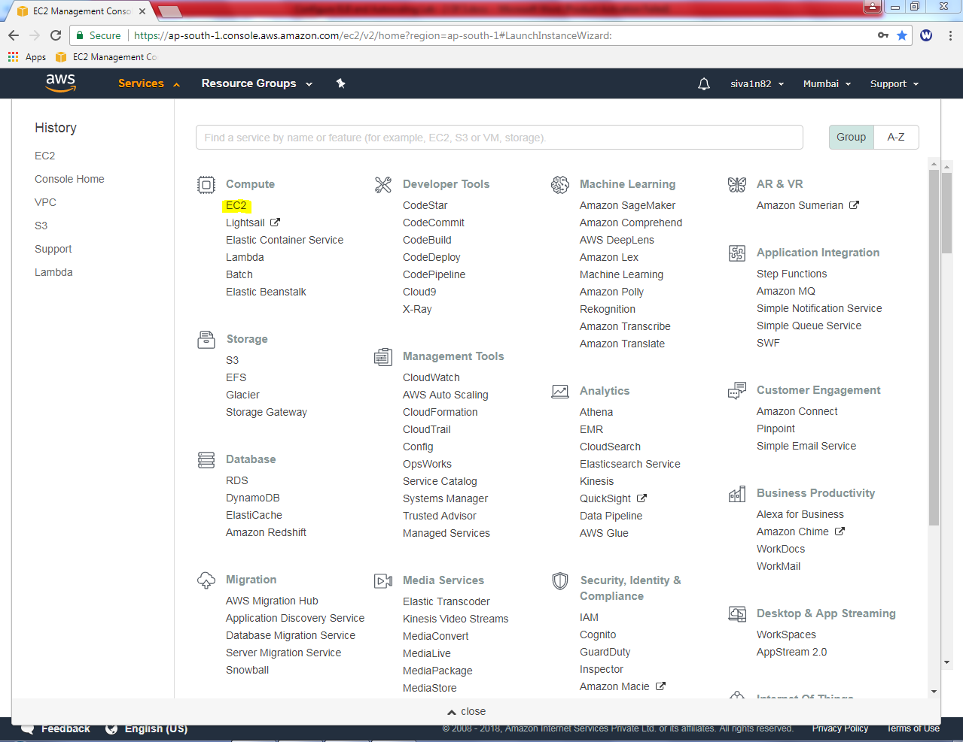

Click “launch instance”.

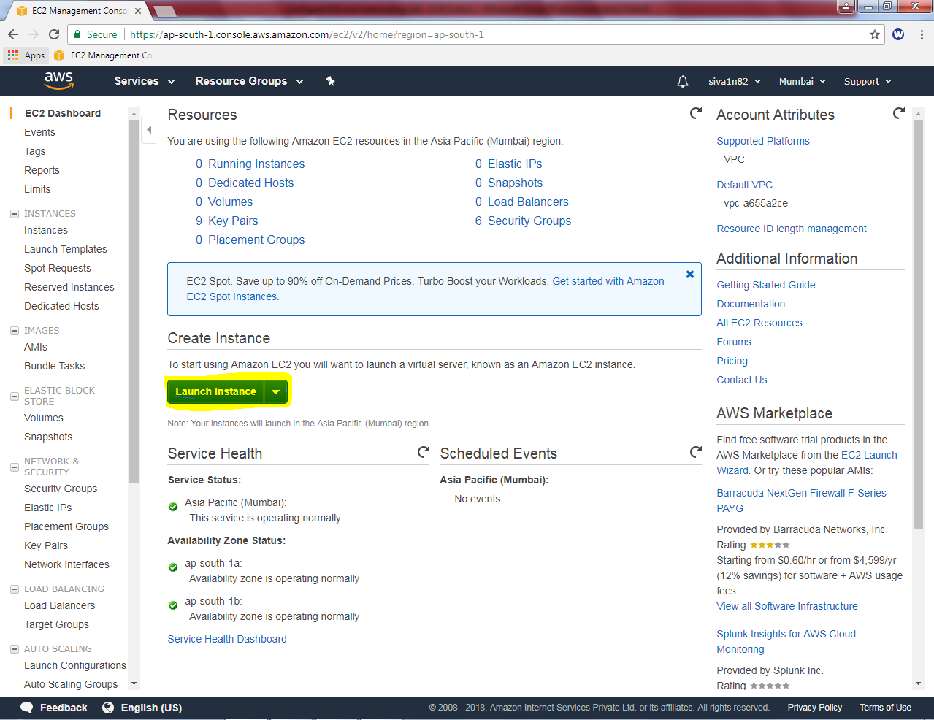

Select “Amazon Linux”.

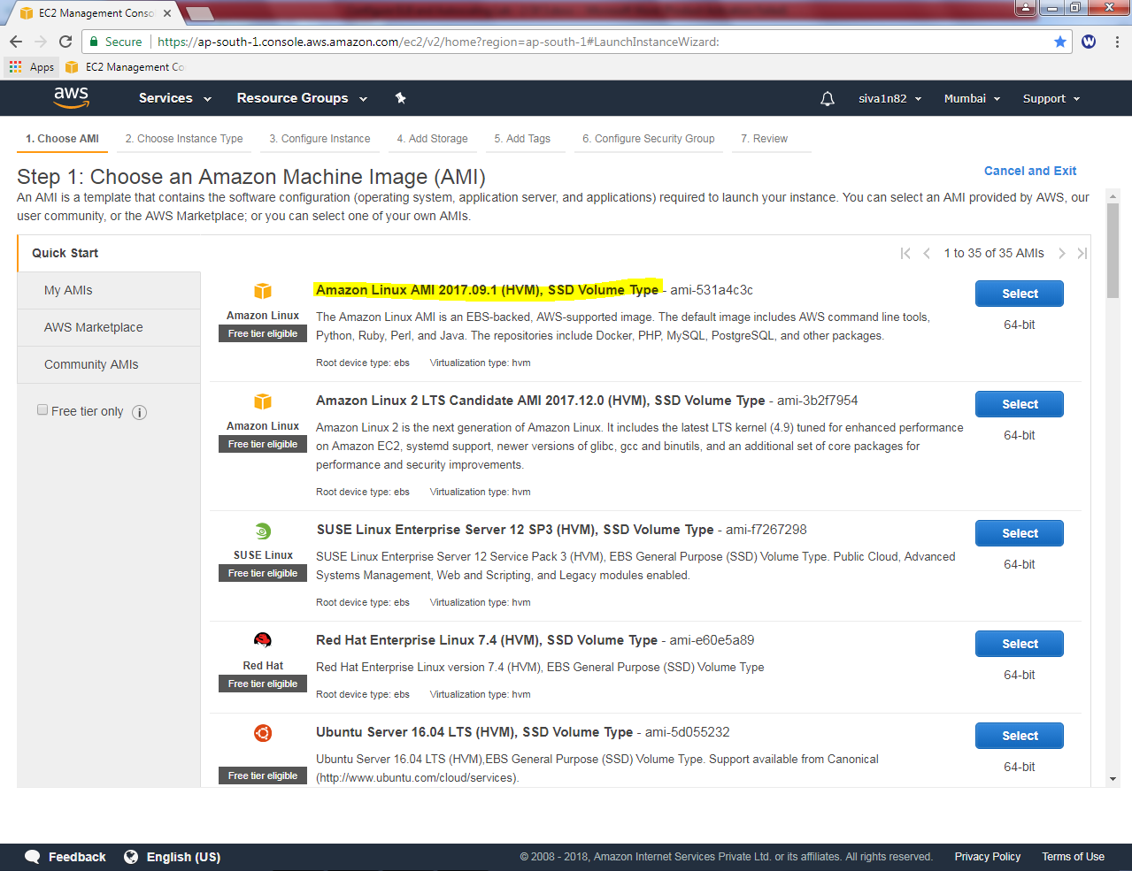

Select “t2.micro”.

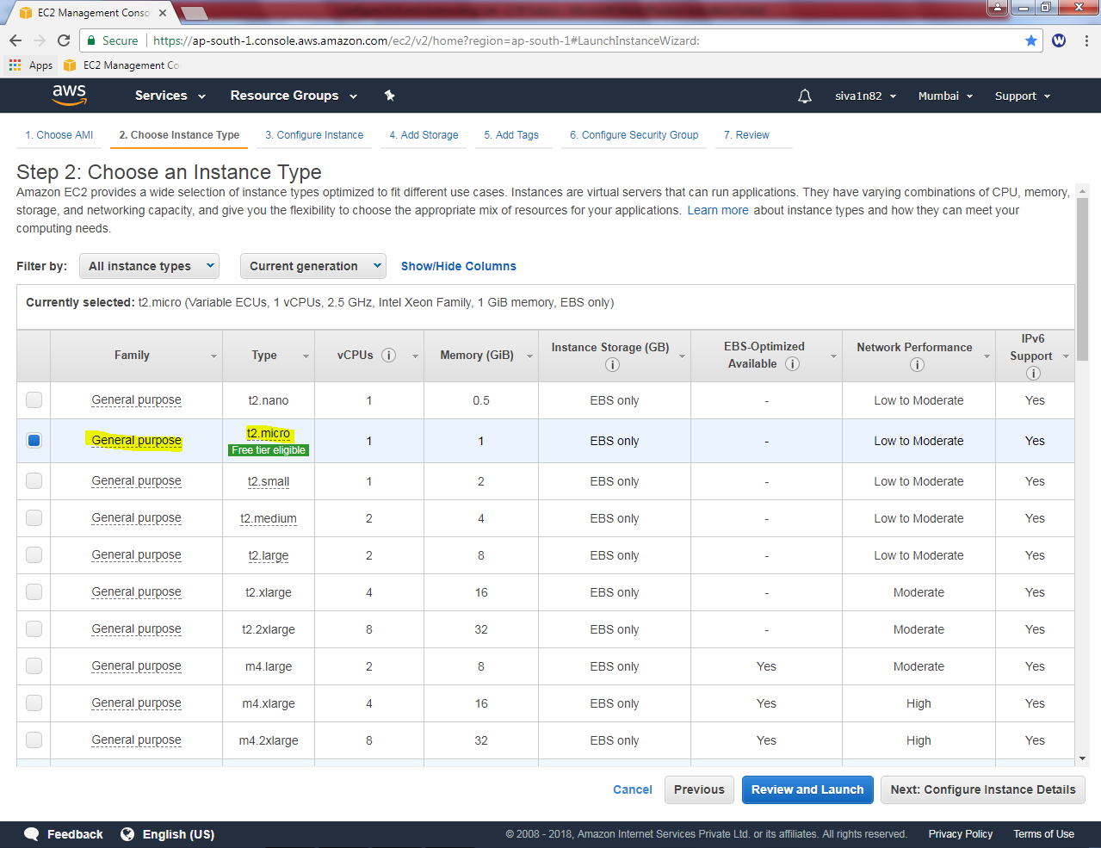

Click “Next”.

Select Network as “Sansbound_VPC_Mumbai”, subnet as “sansbound_mumbai_public_subnet”and Auto-assign Public IP as Enable.

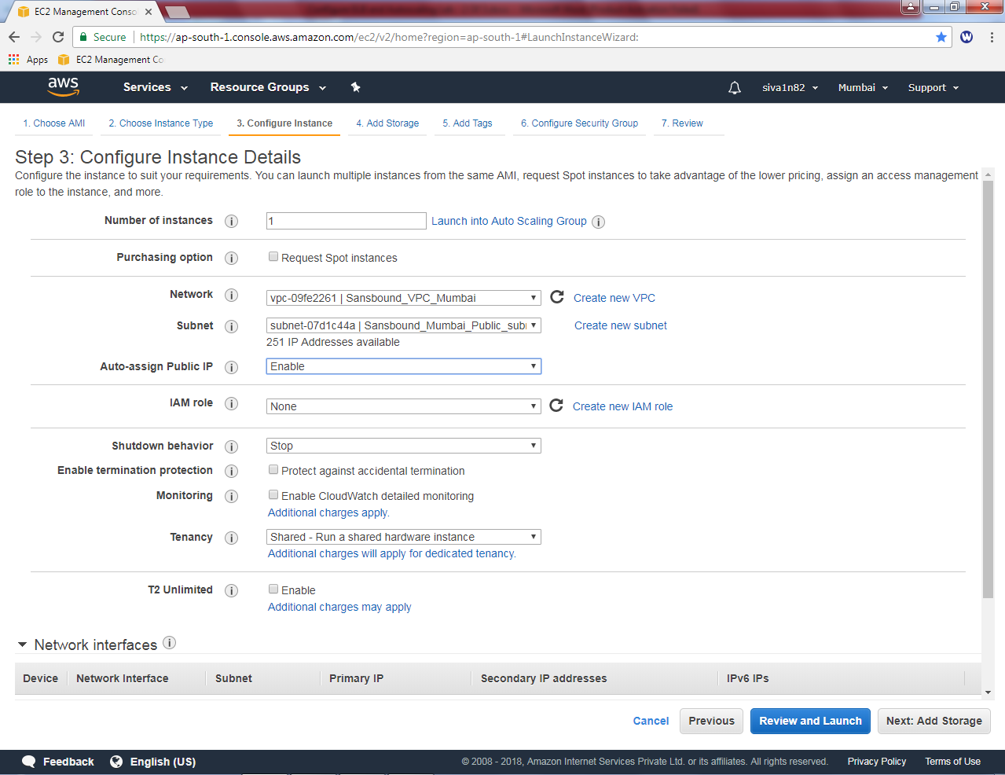

Click ”Next”

Leave default settings and click “Next”.

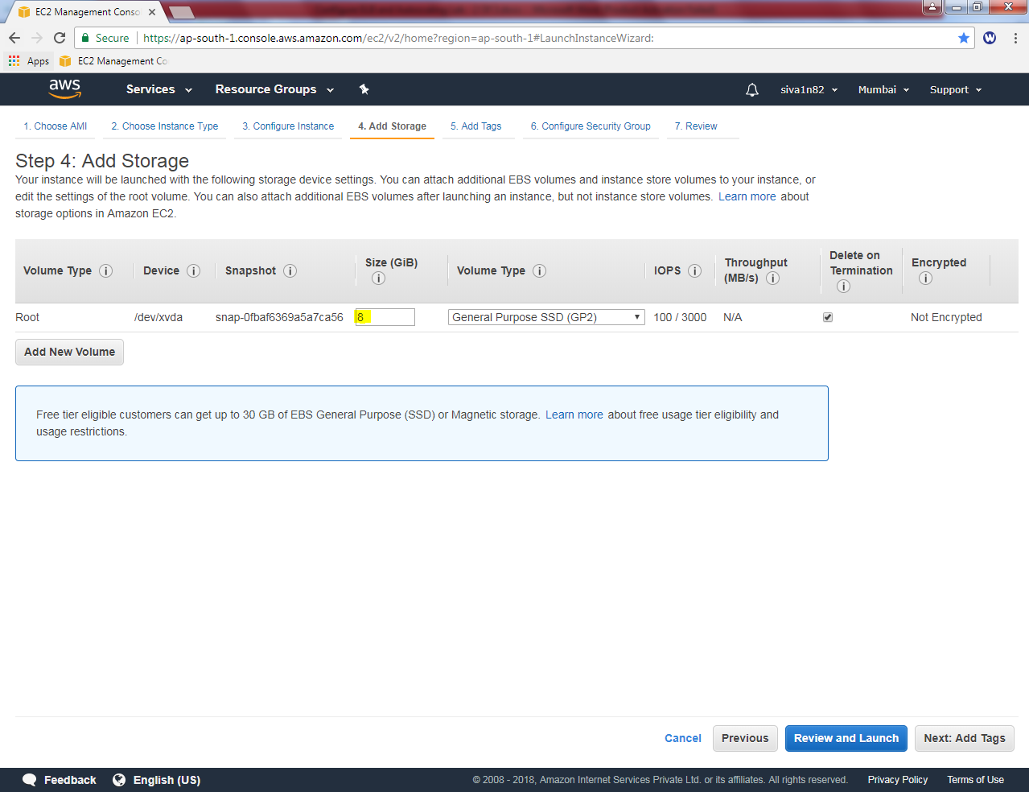

In Add tags, key as Name and value as “webserver”.

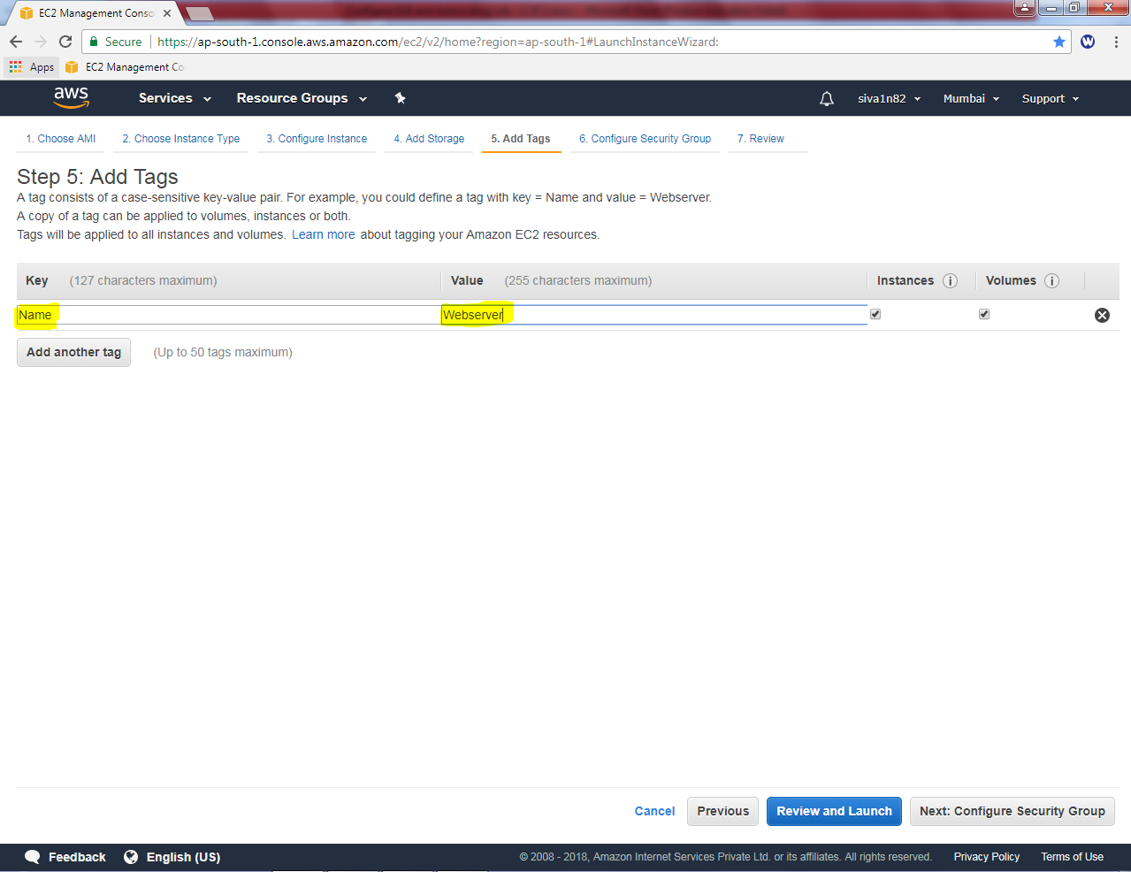

In Security group, create a new security group as “ELB-Sec-Group” and allow SSH and HTTP ports.

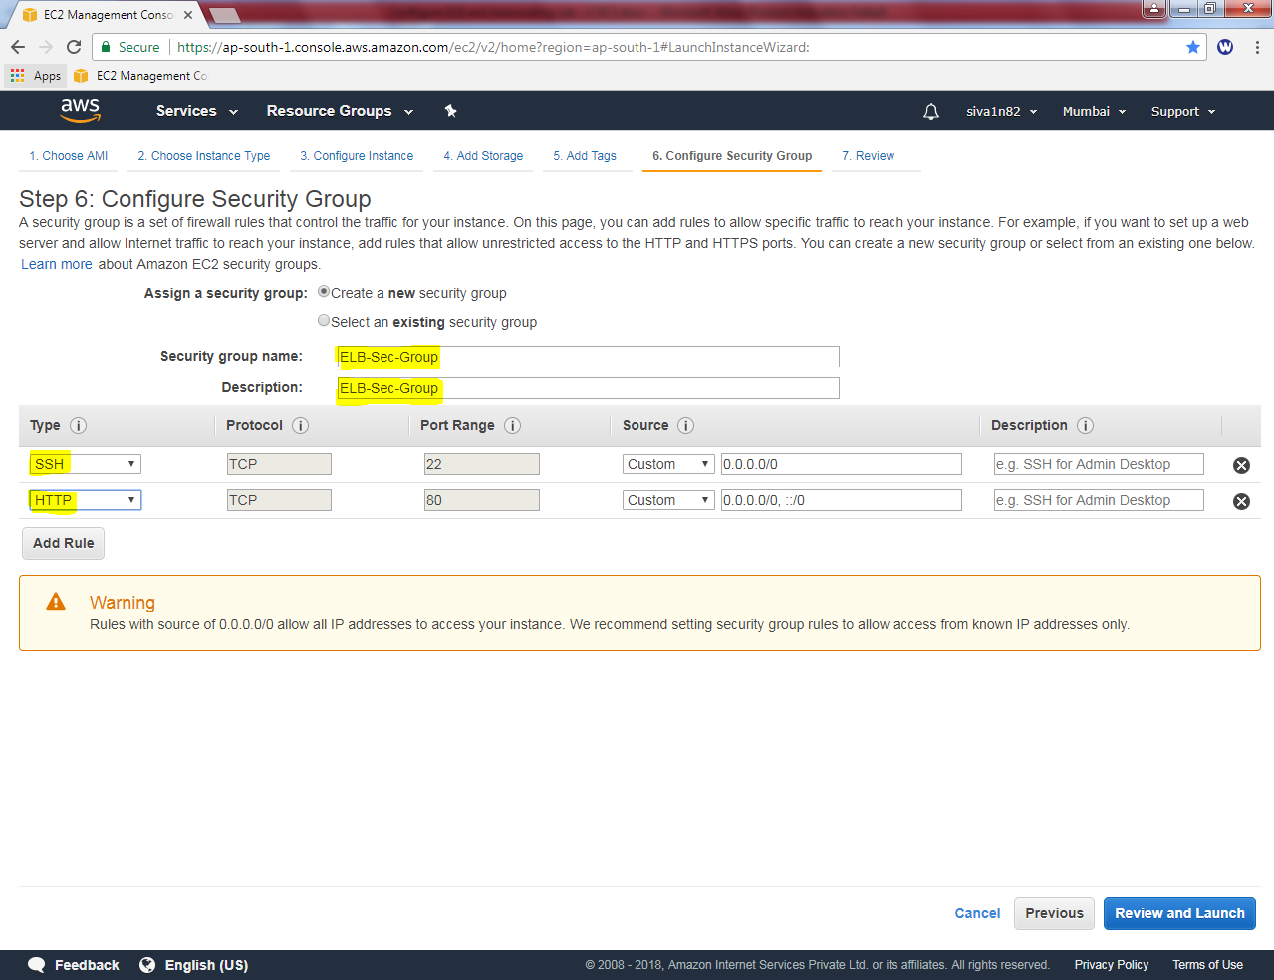

Click “Review and Launch”.

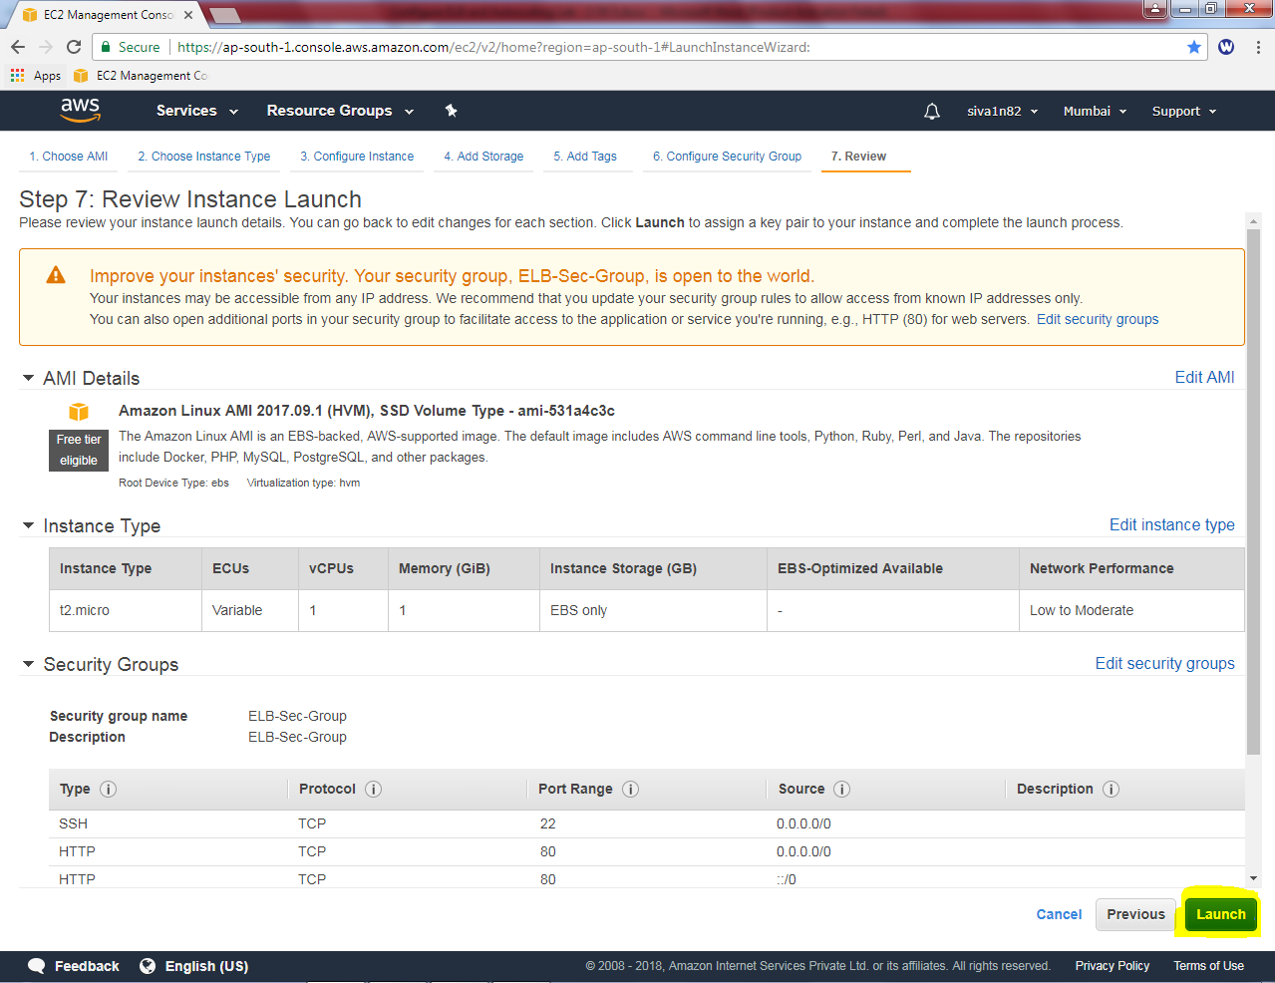

Click “Launch”.

While launch instance, it asked to select an existing key pair or create a new key pair.

Choose an existing key pair.

Then select the key pair.

Click “I acknowledge”check box.

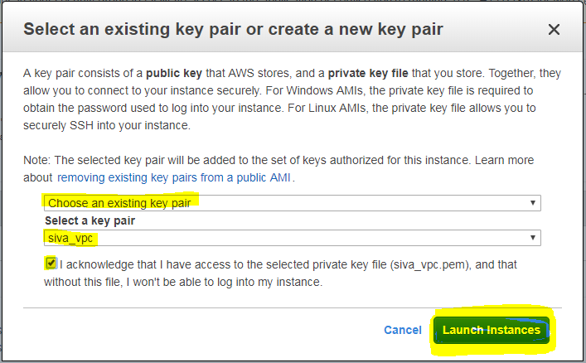

Click “launch instances”.

Click Highlighted area to view instance.

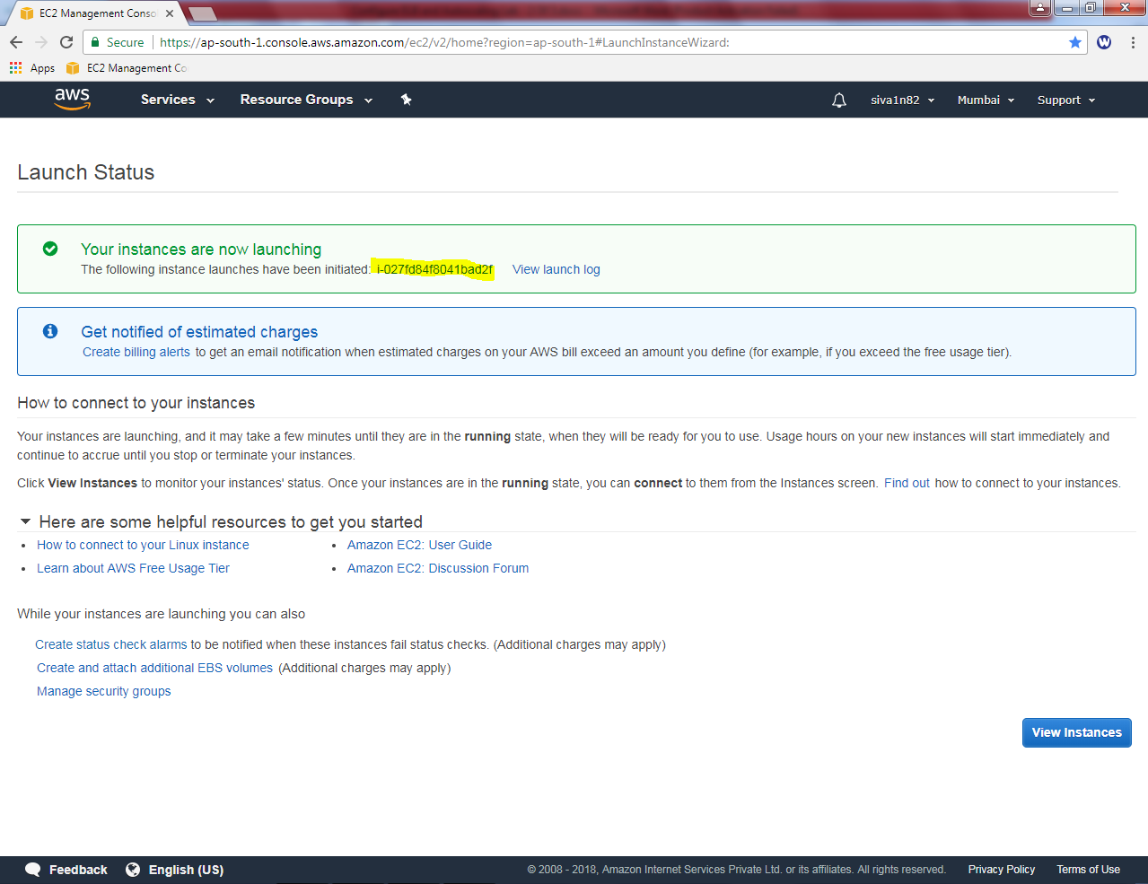

Now we need to launch the instance (LinuX) by using putty,

File 🡪 Load private key

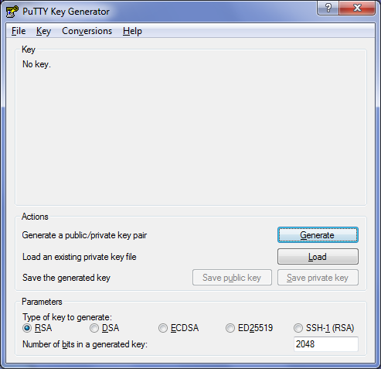

Click “All files ”and locate the *.pem file



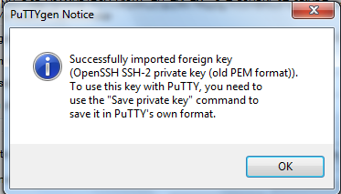

Click “save private key”.

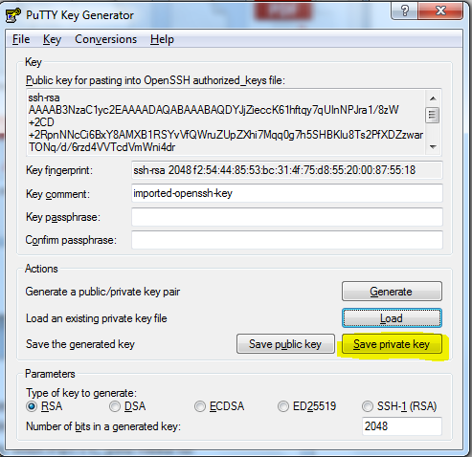

Click “Yes”.

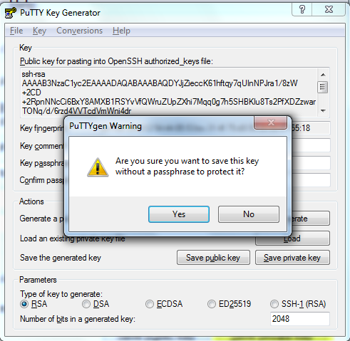

Type the filename to save as ppk file.



Type Public IP address of linux instance in putty,

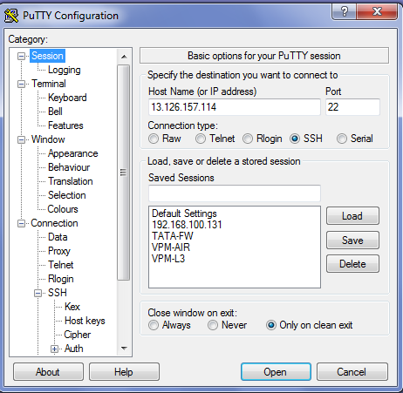

In SSH expand the plus symbol, click Auth, and browse the ppk file.

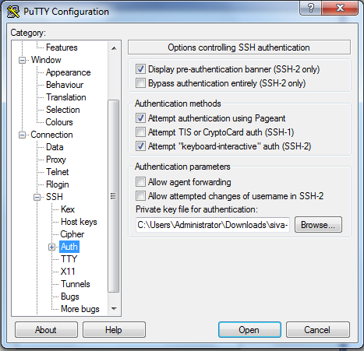

Click “Open”.

Click “Yes”

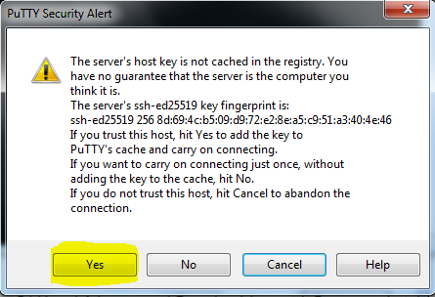

Type user as **ec2-user**

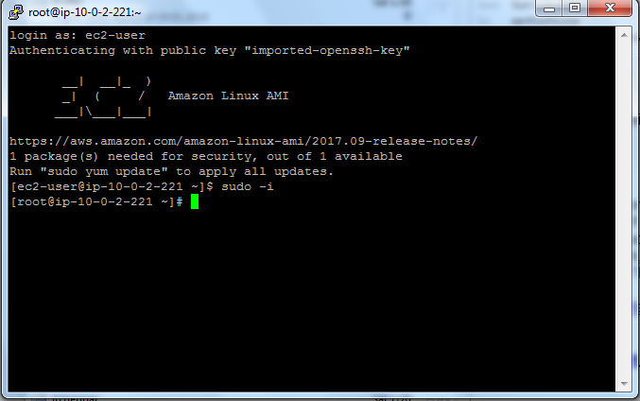

Then type ***sudo –i***

Then we need to install apache webserver in linux by using below mentioned command

***Yum install httpd***

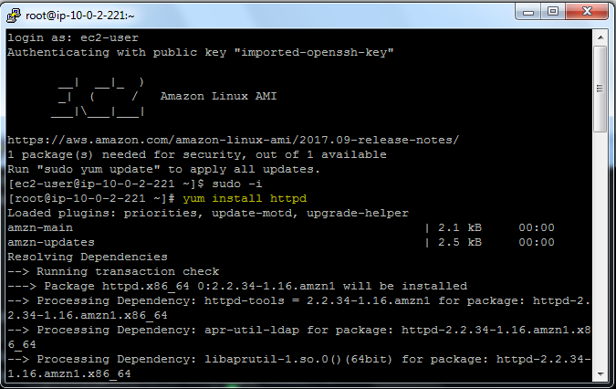

***Service httpd start***

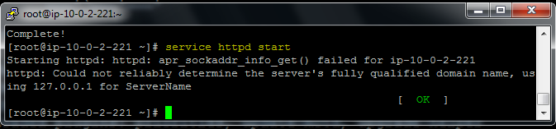

***Chkconfig httpd on***

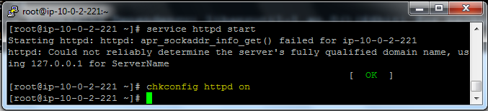

Type cat > /var/www/html/index.html

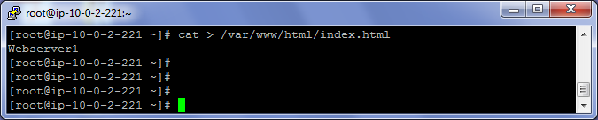

***Type the webserver1***

***Press enter***

***Then click Ctrl + D***

Now we need to create an image for Linux instance.

Select instance, right click click image🡪 create image.

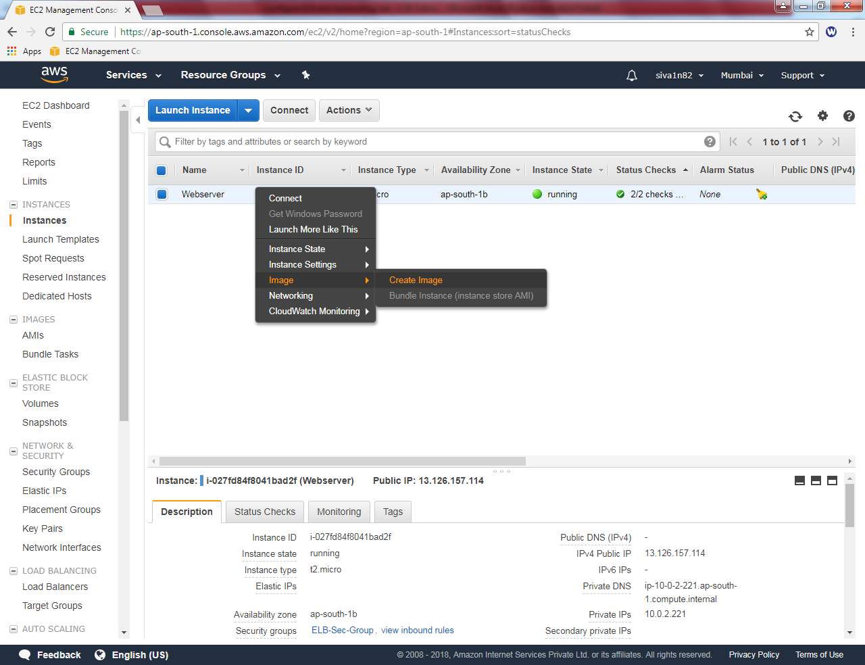

Type image name as “Sansbound webserver”

Image description as “ELB Testing”.

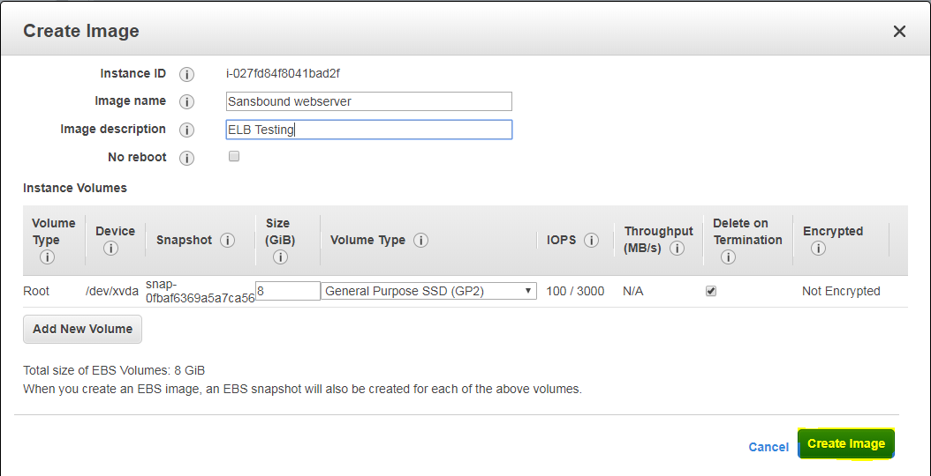

Click “create image”.

To view the image , click “AMI”. Wait up to the state is **available.**

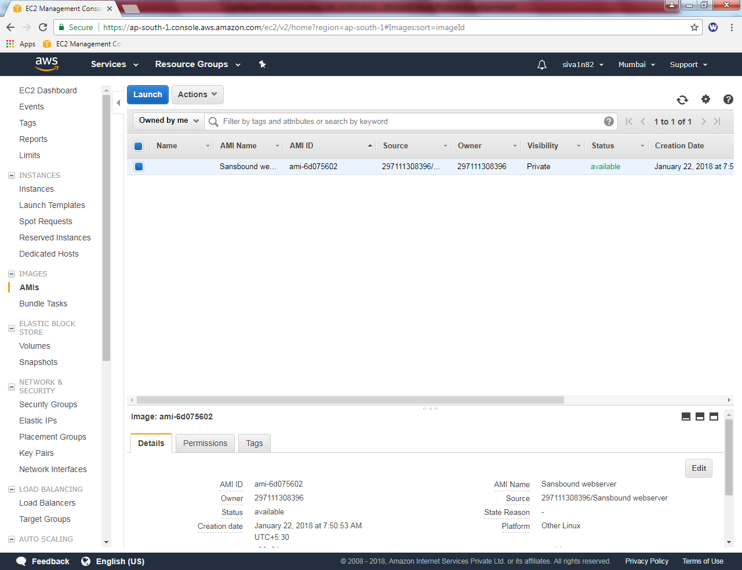

Click “Launch”.

Click “My AMIs” and select “Sansbound webserver”.

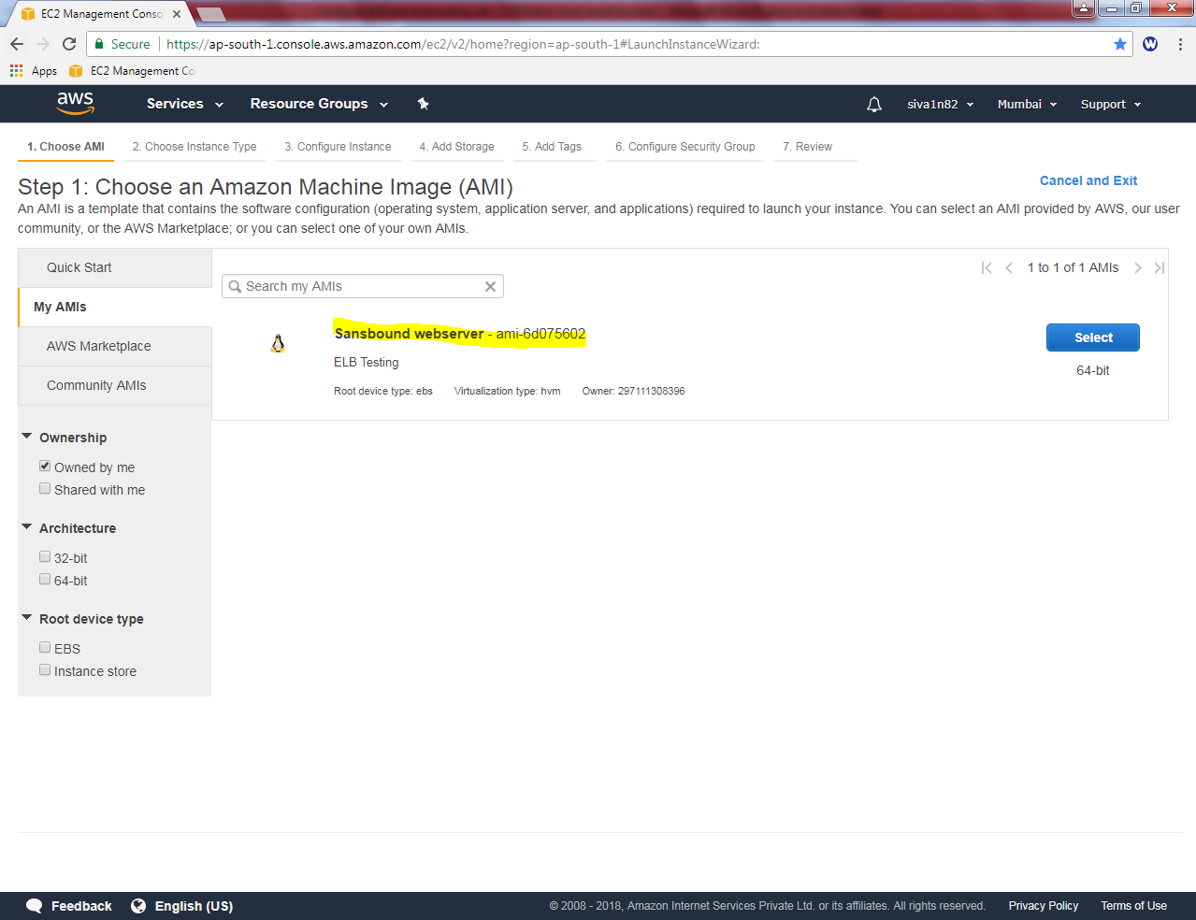

Select “t2.micro”.

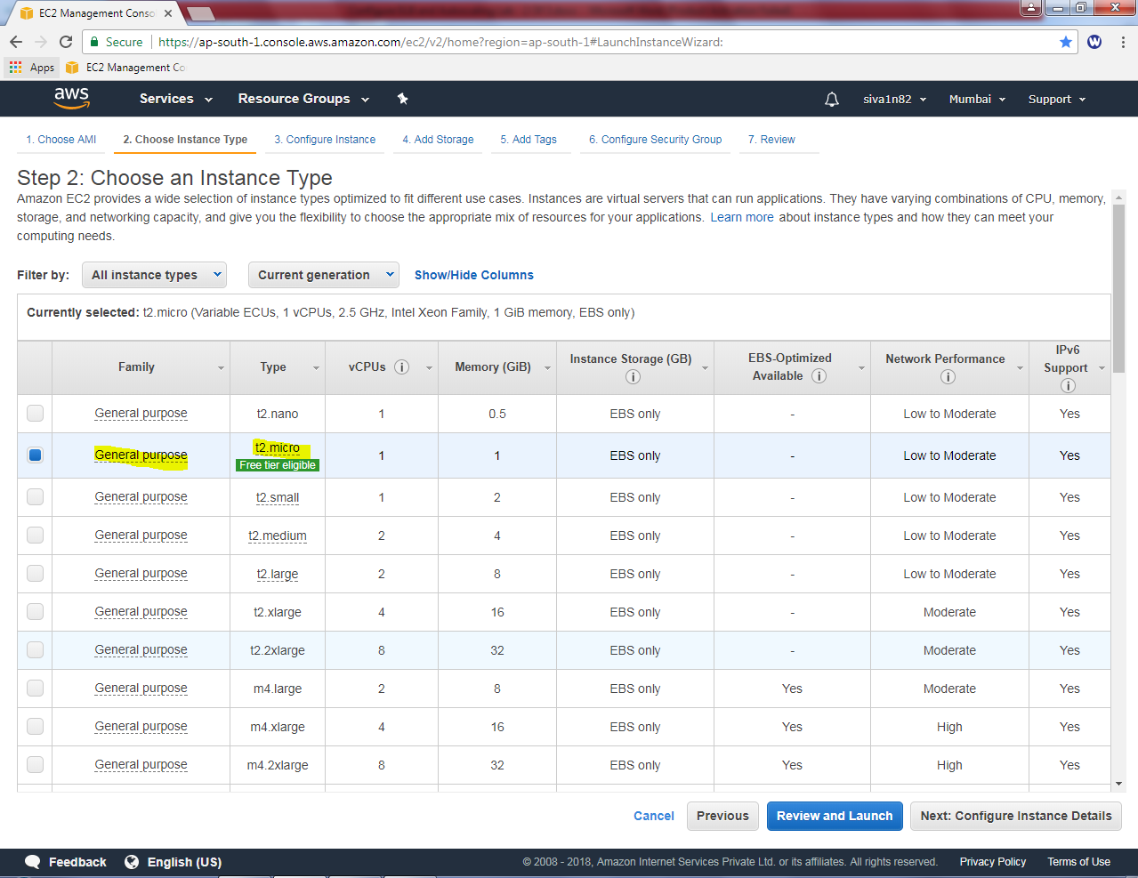

Click “Next”.

Create an Number of instances as “2”.

Network as Sansbound_VPC_Mumbai

Subnet as Sansbound_mumbai_Public_subnet

Auto-assign public IP: Enable.

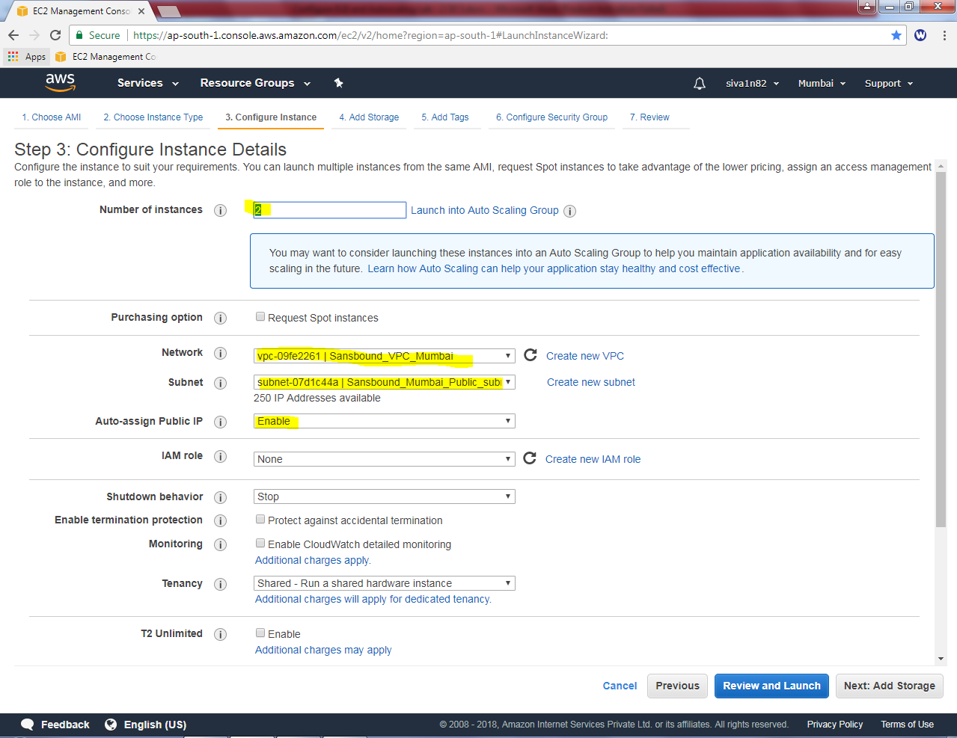

Click “Next”.

Leave as default and click “Next”.

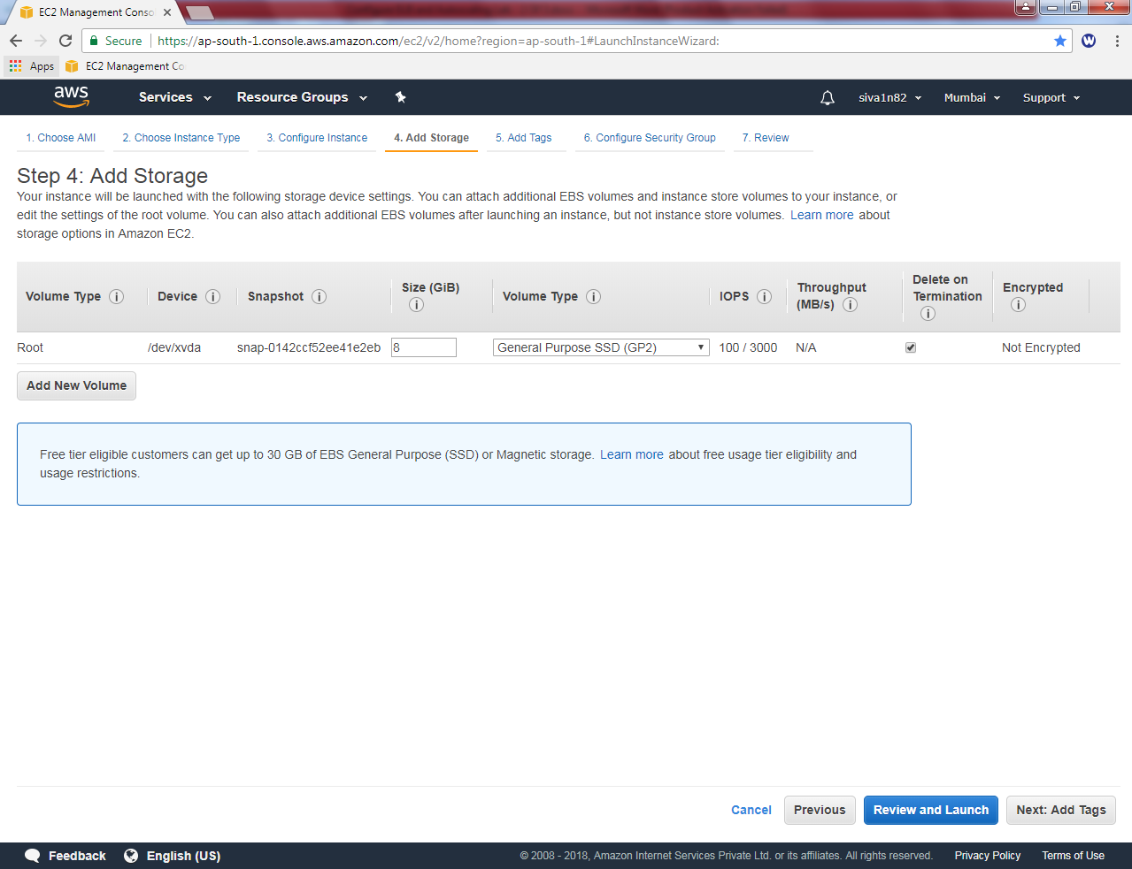

In Add tags, Name: Webserver

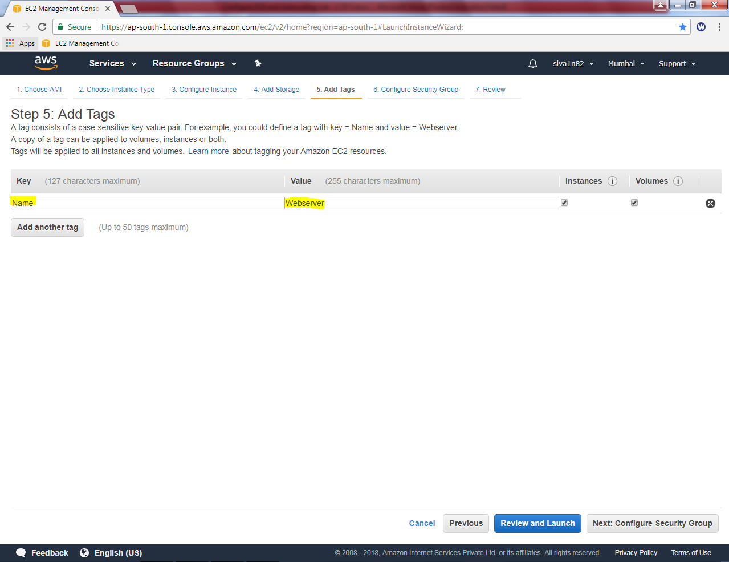

Click “Next”.

Select “ELB-Sec-Group”

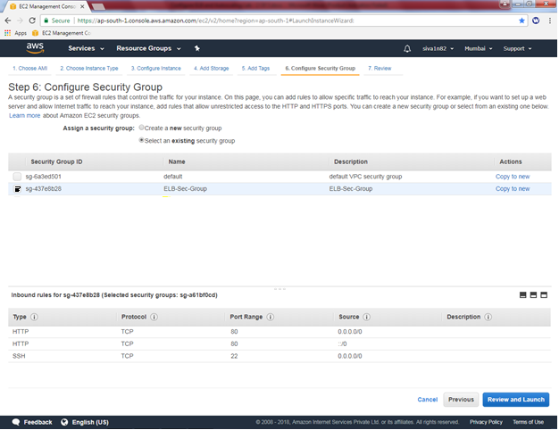

Click “Review and Launch”.

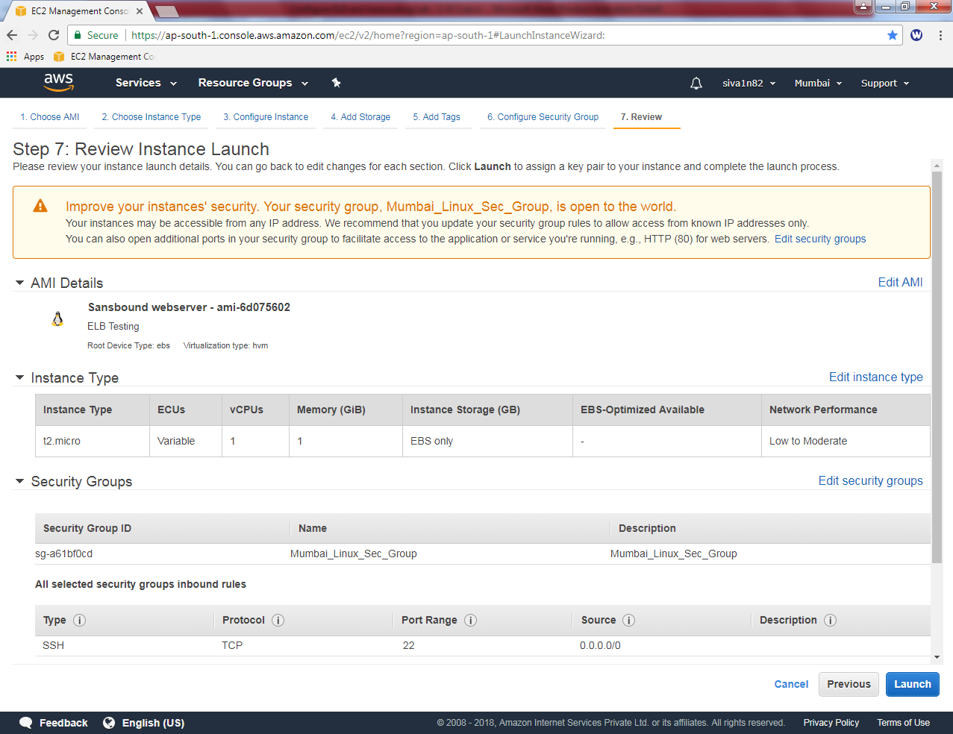

Click “Launch”.

While launch instance it asks Select an existing key pair or create a new key pair.

I will choose “Choose an existing key pair”

Select a key pair “siva_vpc”.

Click “I acknowledge”.

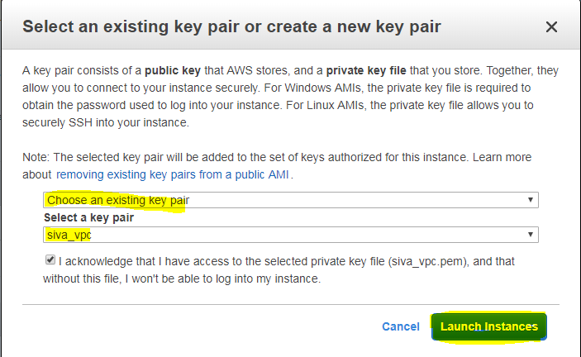

Click “Launch instances”.

Wait upto status checks becomes 2/2 checks, now 3 servers (Linux) are up and running.

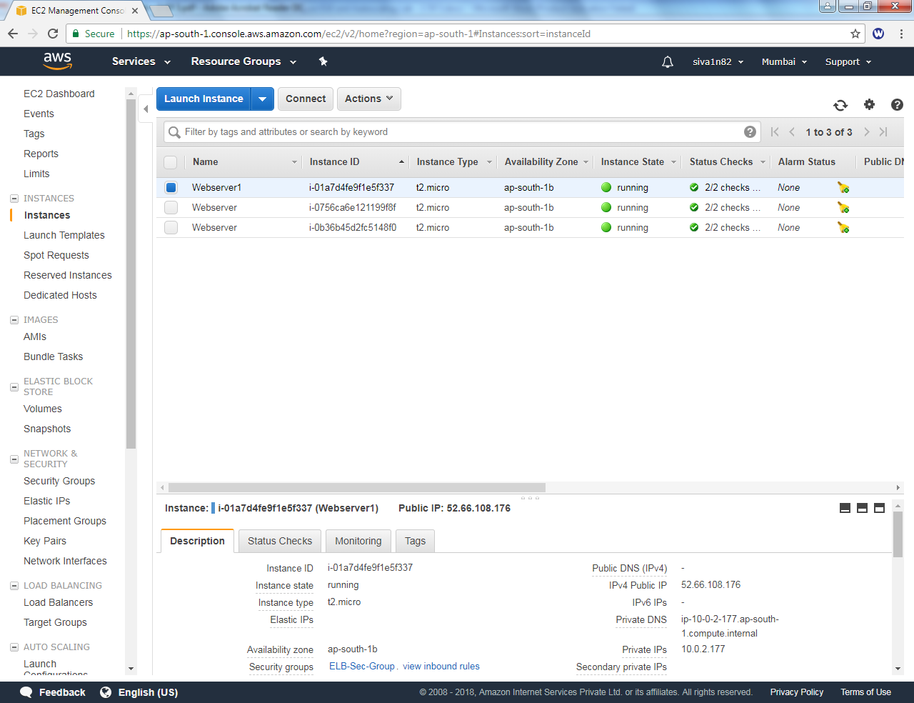

Need to rename the Linux servers name as webserver2 and webserver3.

You have renamed the server name successfully.

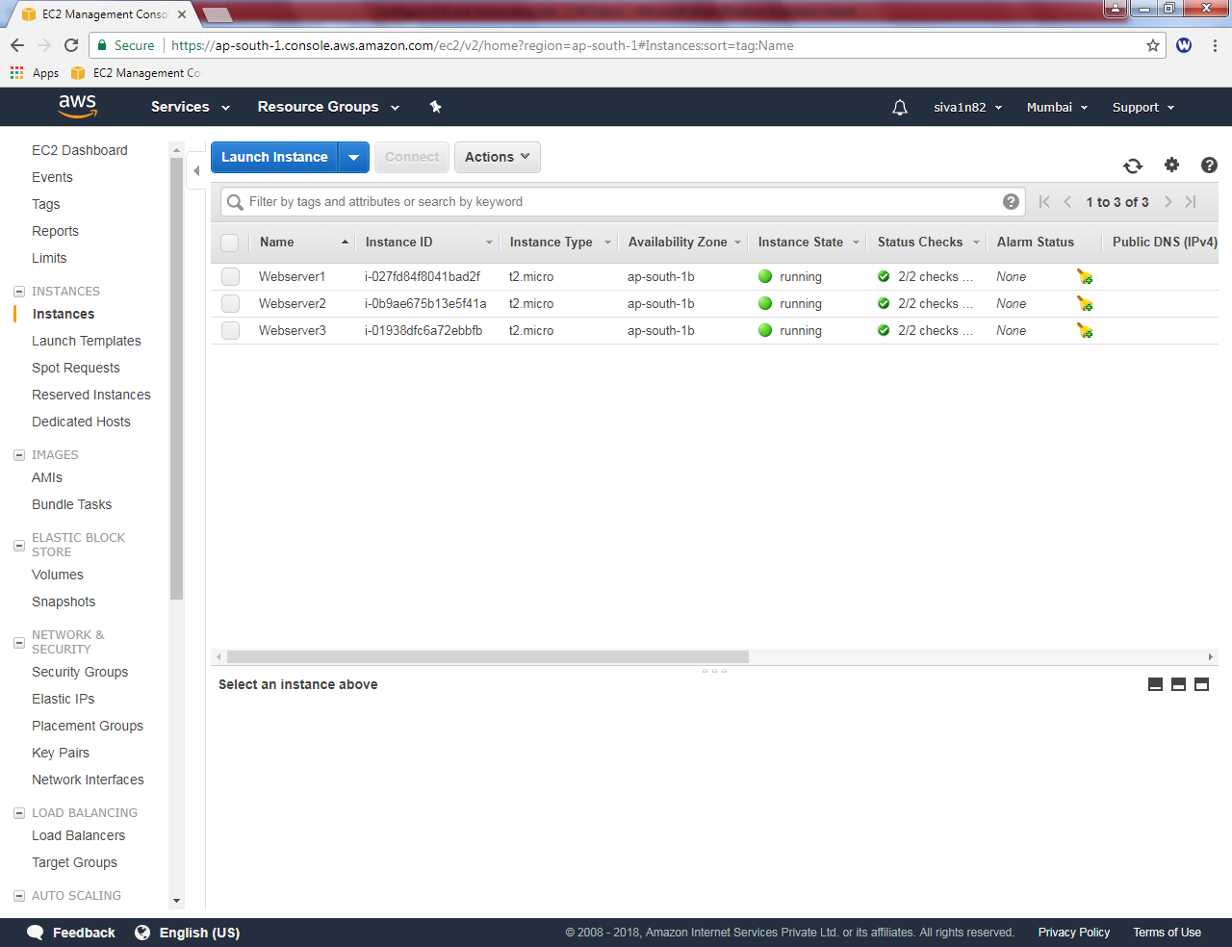

Login to webserver2

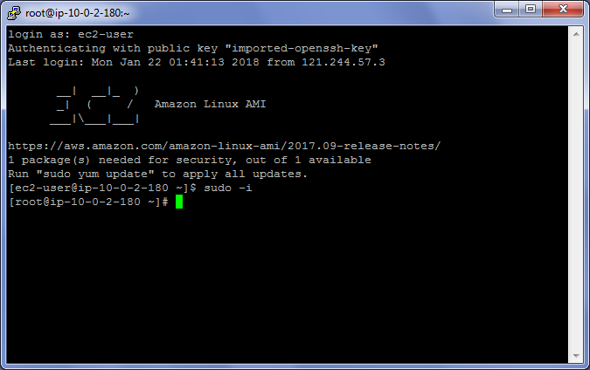

Type ***cat > /var/www/html/index.html***

***webserver2***

Press enter

Then click Ctrl + D

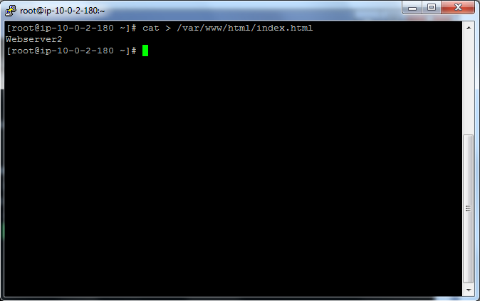

Login to webserver3

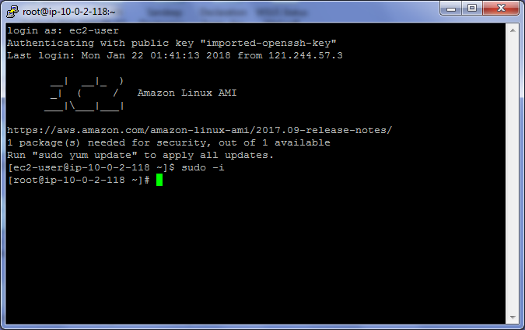

Type ***cat > /var/www/html/index.html***

***Webserver3***

Press enter

Then click Ctrl + D

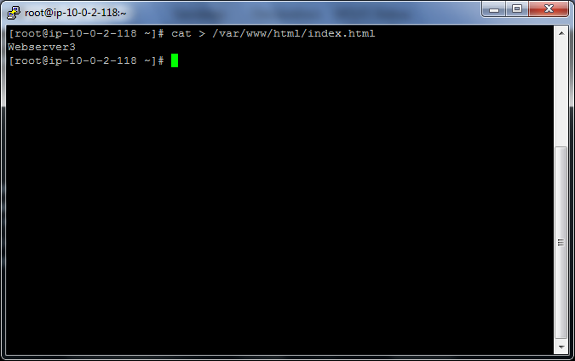

Able to access webserver1 publicly



Able to access webserver2 publicly



Able to access webserver3 publicly



Now we need to configure Load balancer. In EC2 dashboard, click “Load balancers”

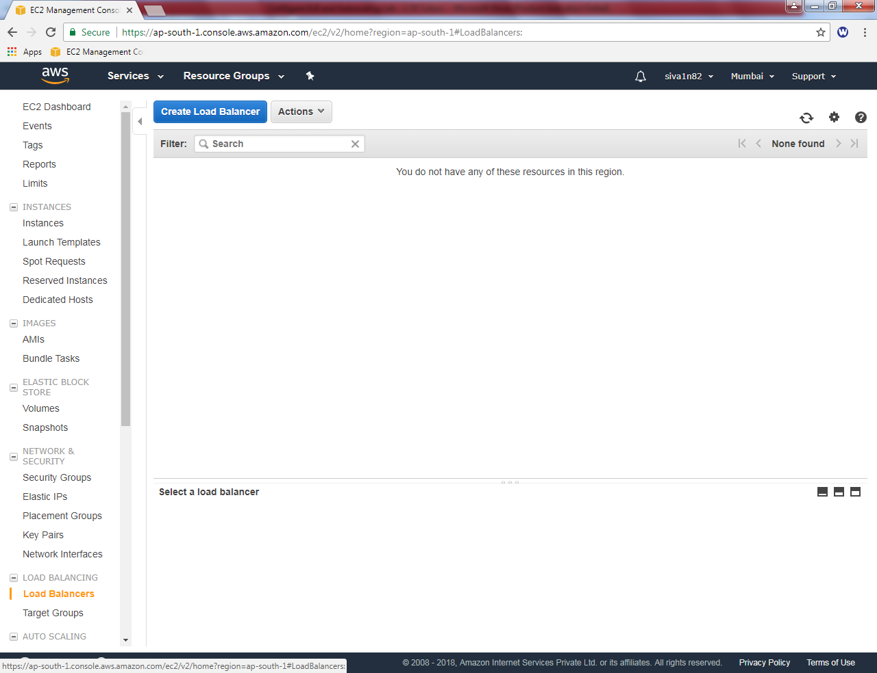

Click “Create Load balancer”

Click “classic Load balancer”

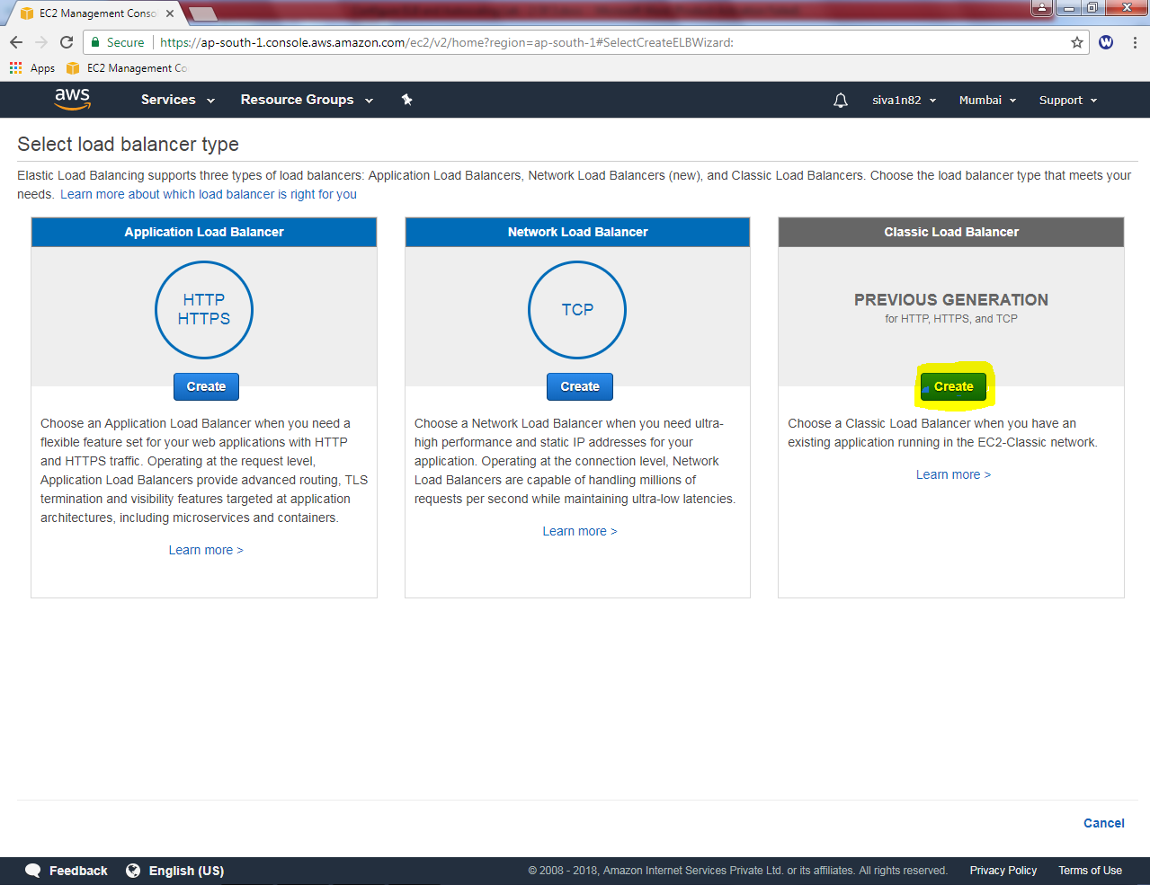

Load balancer name: SansboundELB

Create LB Inside : Select Sansbound_VPC_Mumbai

In Load balancer protocol select “TCP””

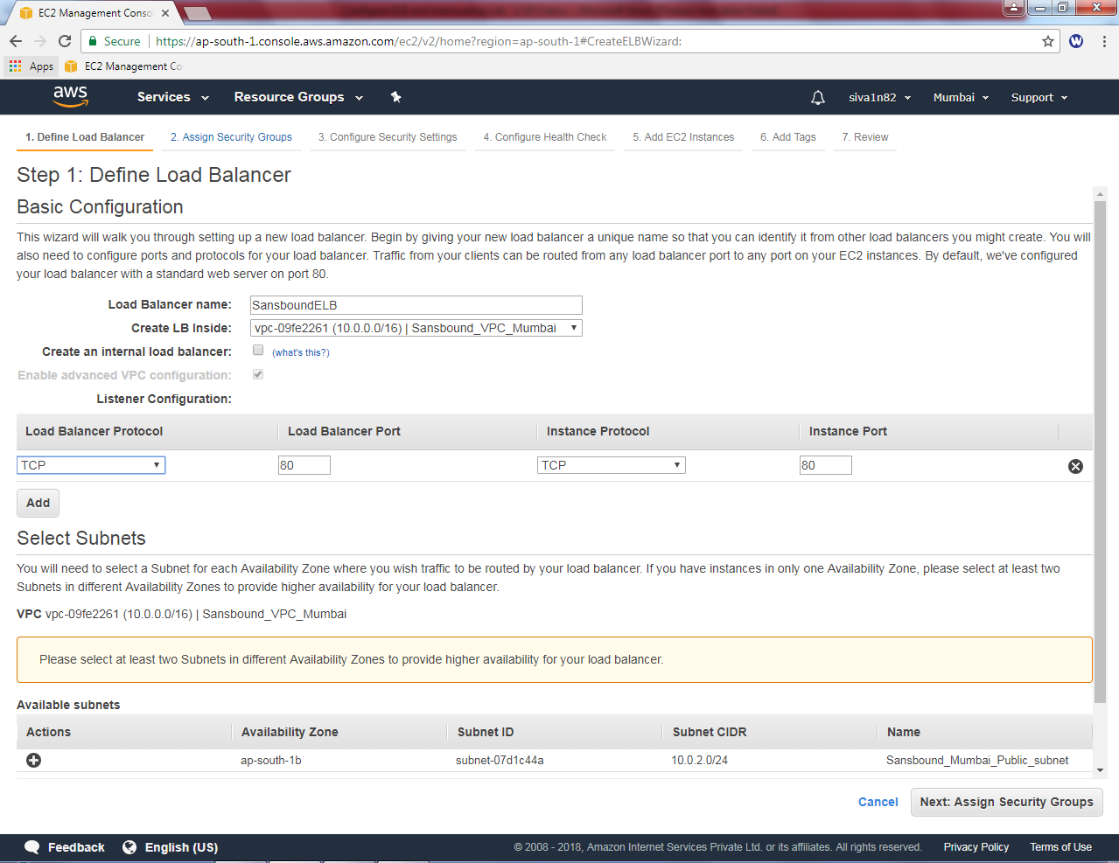

Click “+” symbol to select the subnet.

You can able to see the 10.0.2.0/24 subnet has been selected.

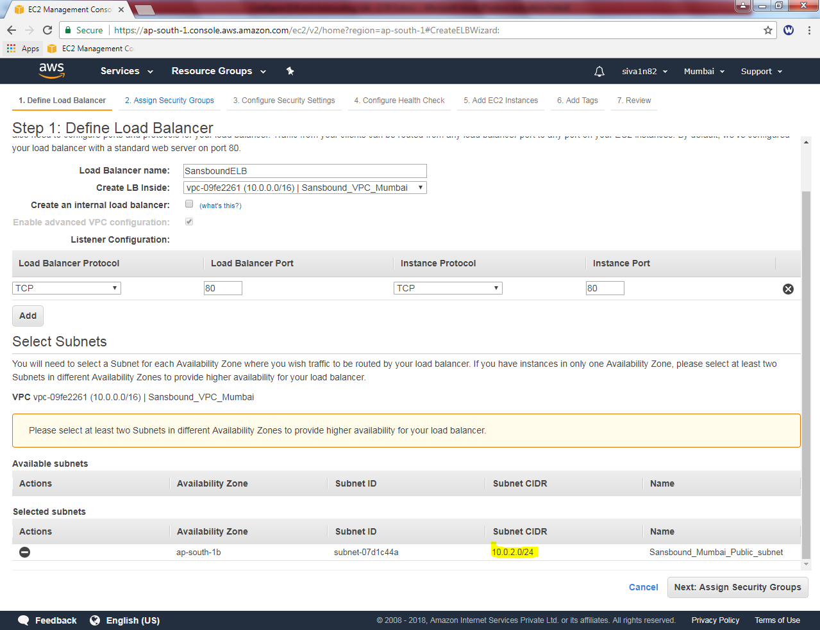

Click “Next”.

Select “ELB-Sec-Group”

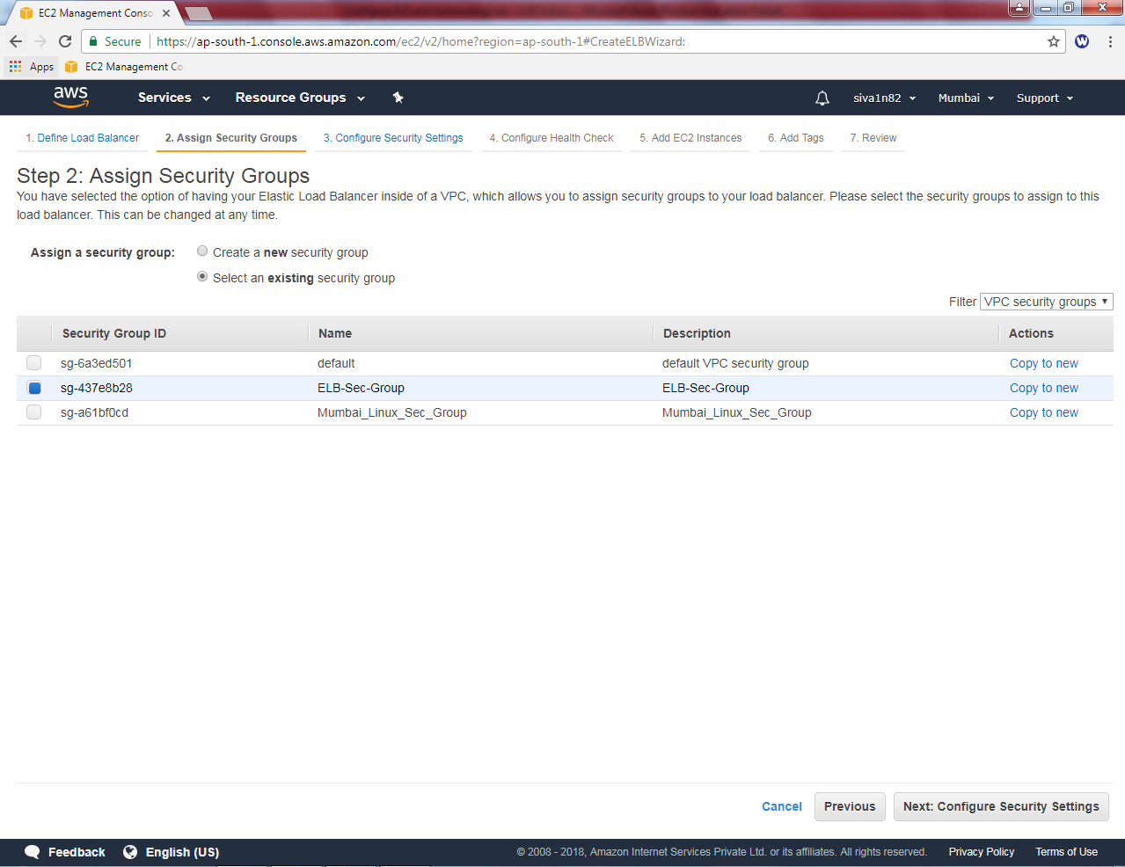

Click “Next”.

Click “Next”.

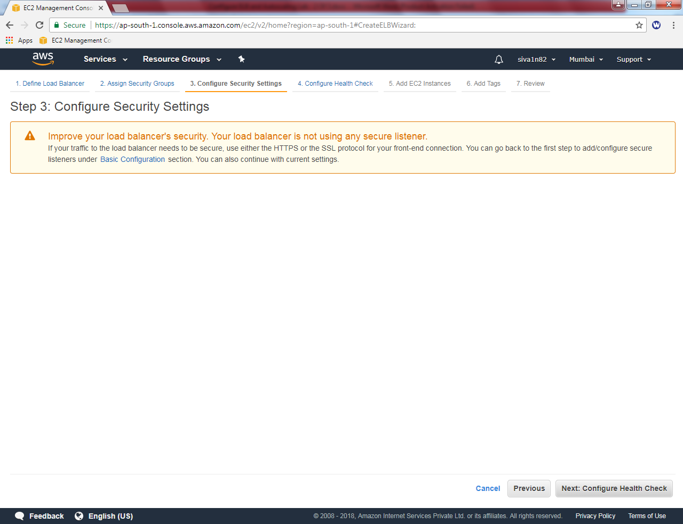

Click “Next”.

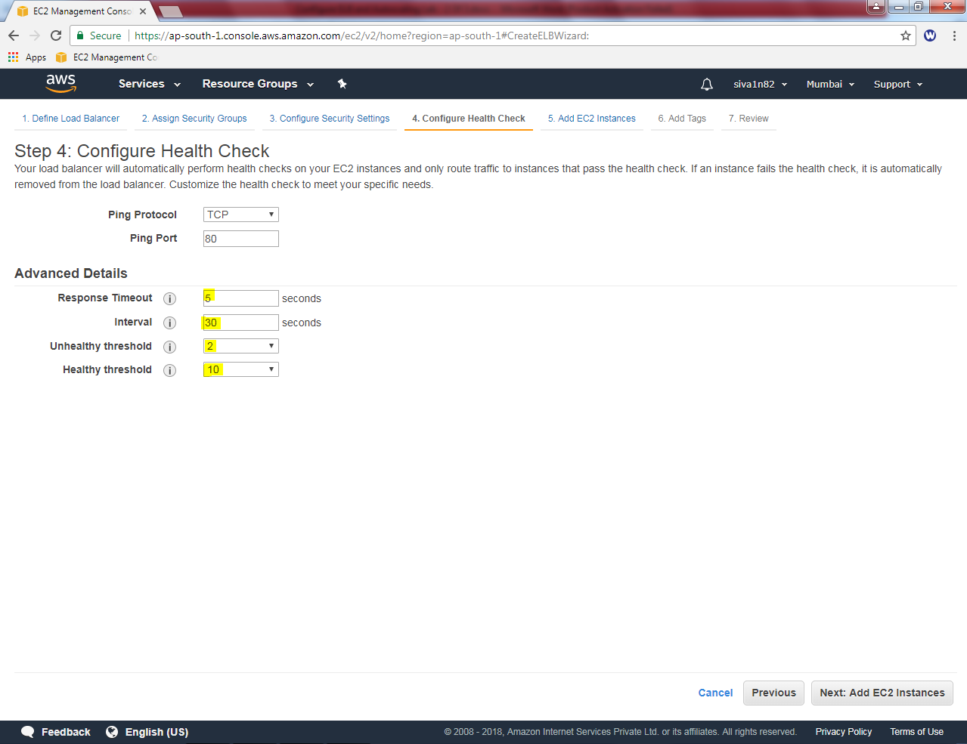

Need to click Three linux instances to add in load balancer.

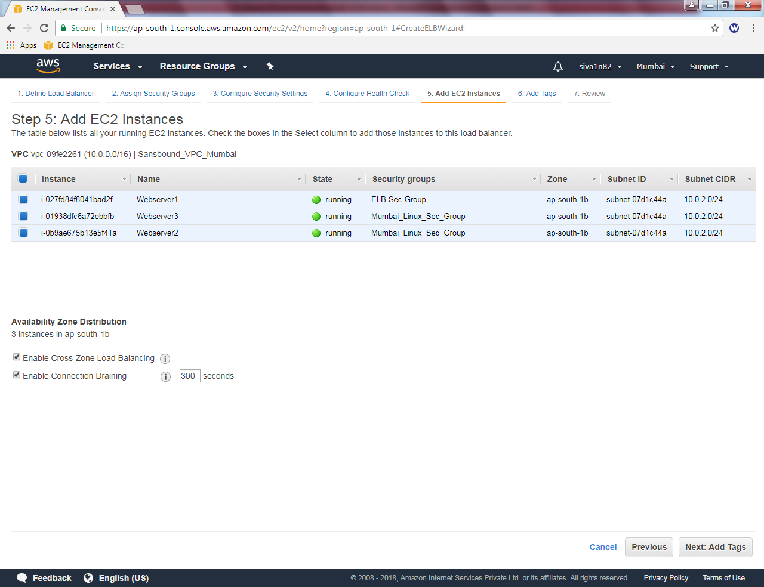

Click “Next”.

In Add tags, Key as Name and value as “Webserver”

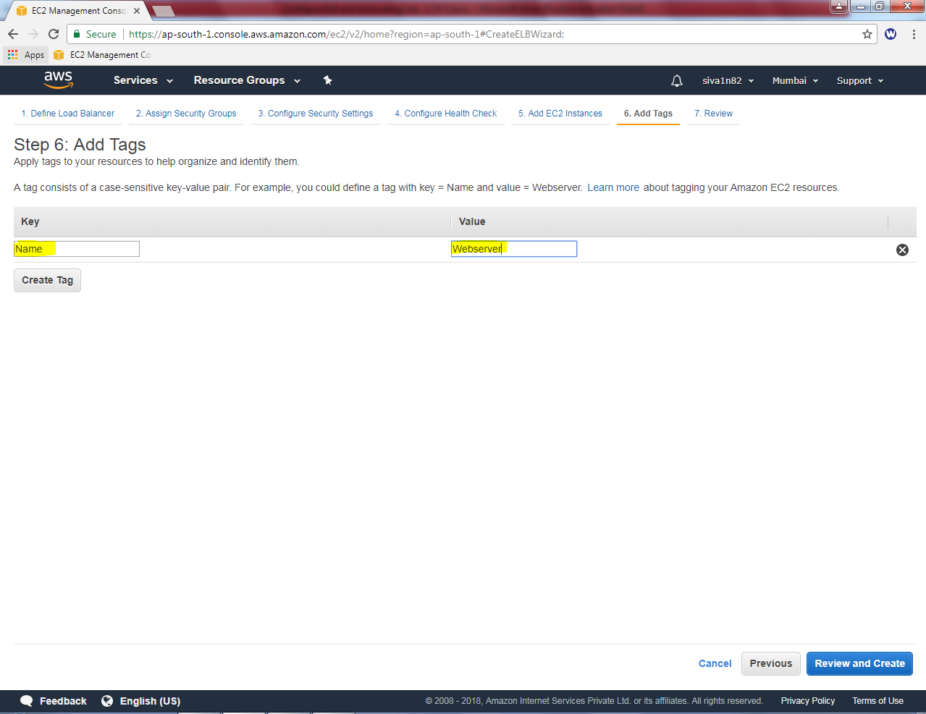

Click “Review and create”.

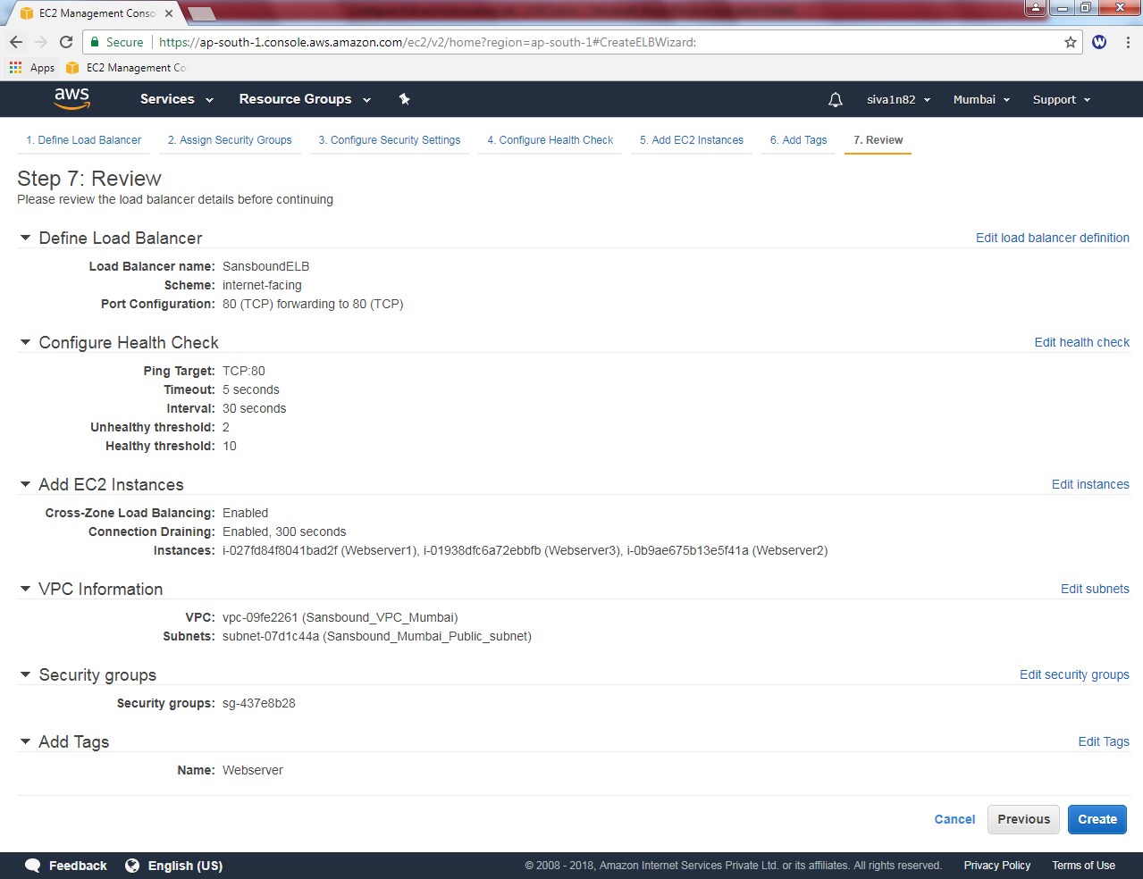

Click ”create”.

Now load balancer has been successfully created.

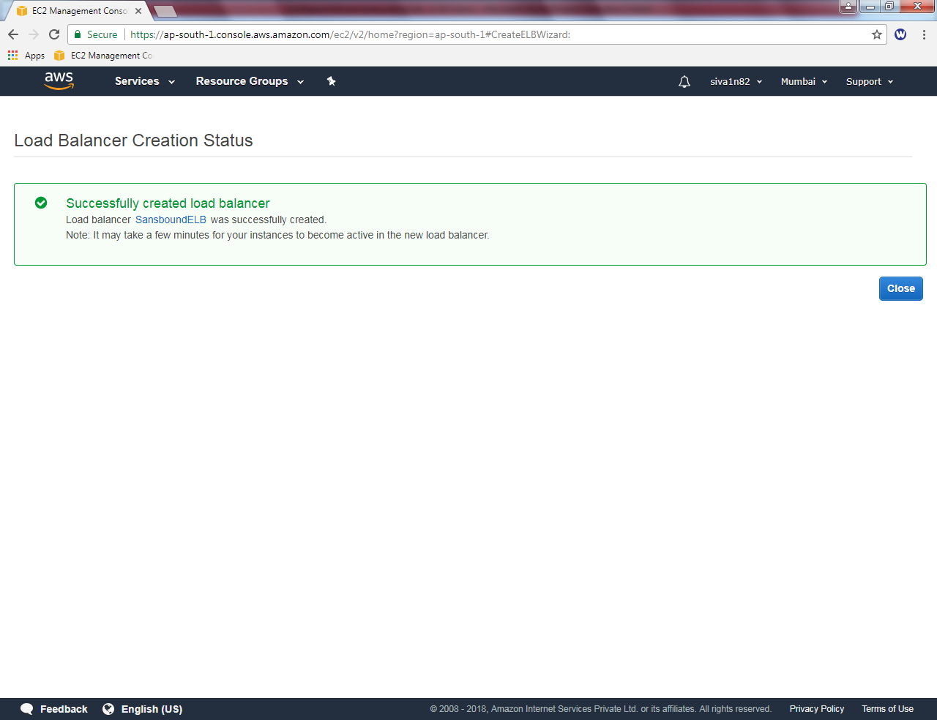

Click load balancer, Click “Instances”, to view the instance status. Click refresh frequently to get the status of instance. By default it is in out of service state.

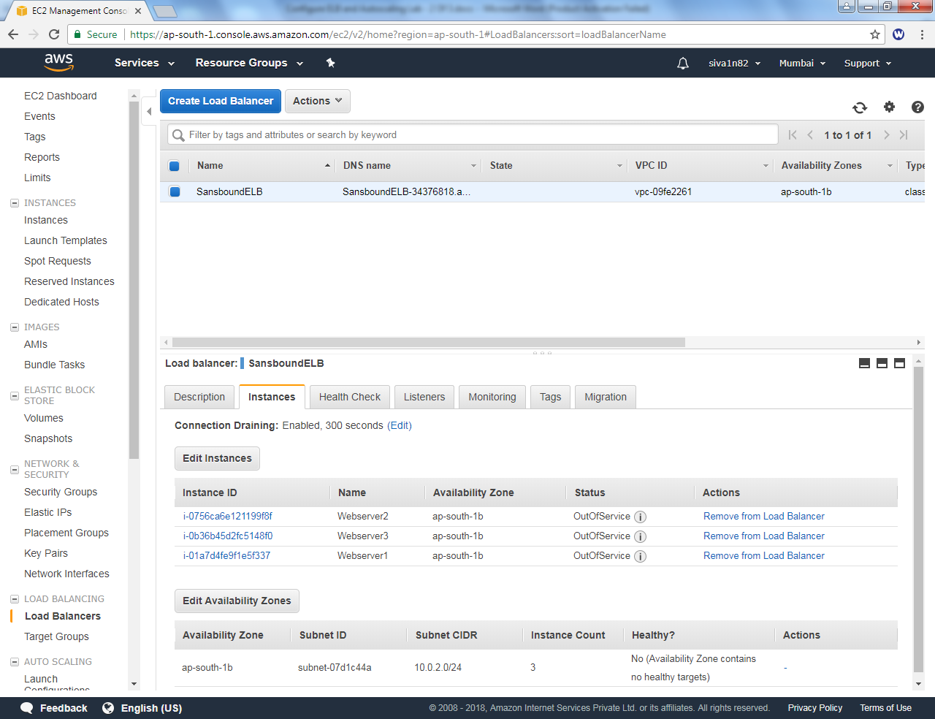

Click refresh and wait for 1-2 minutes It should be **“In service”** instead of out of service.

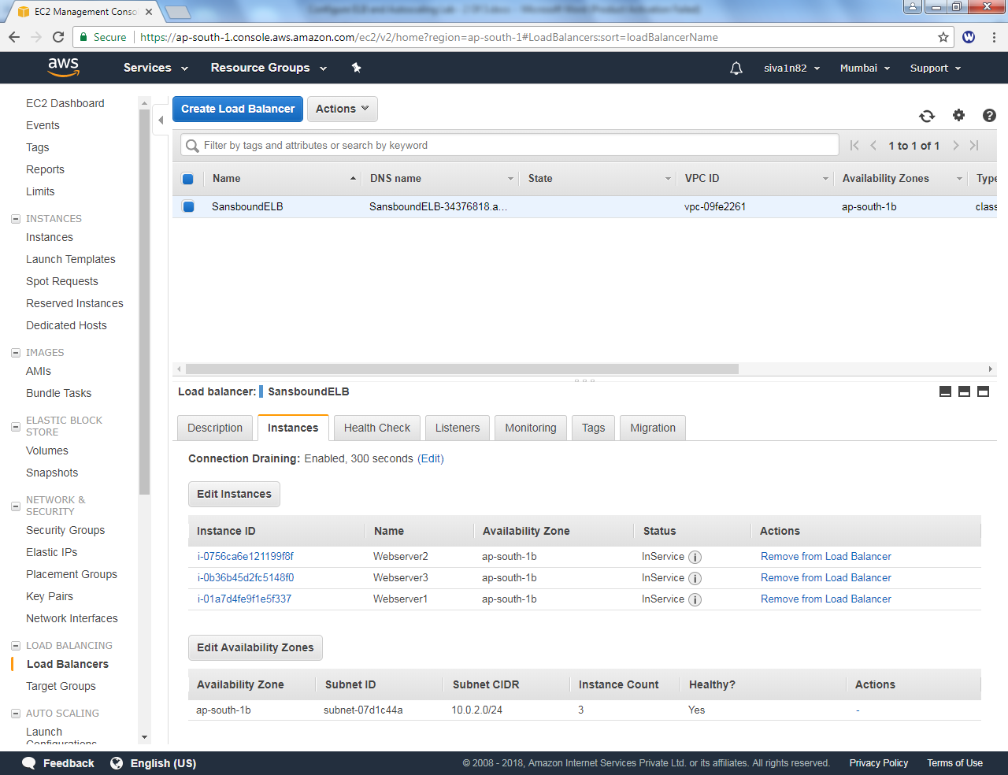

Copy the URL and try to connect from chrome.

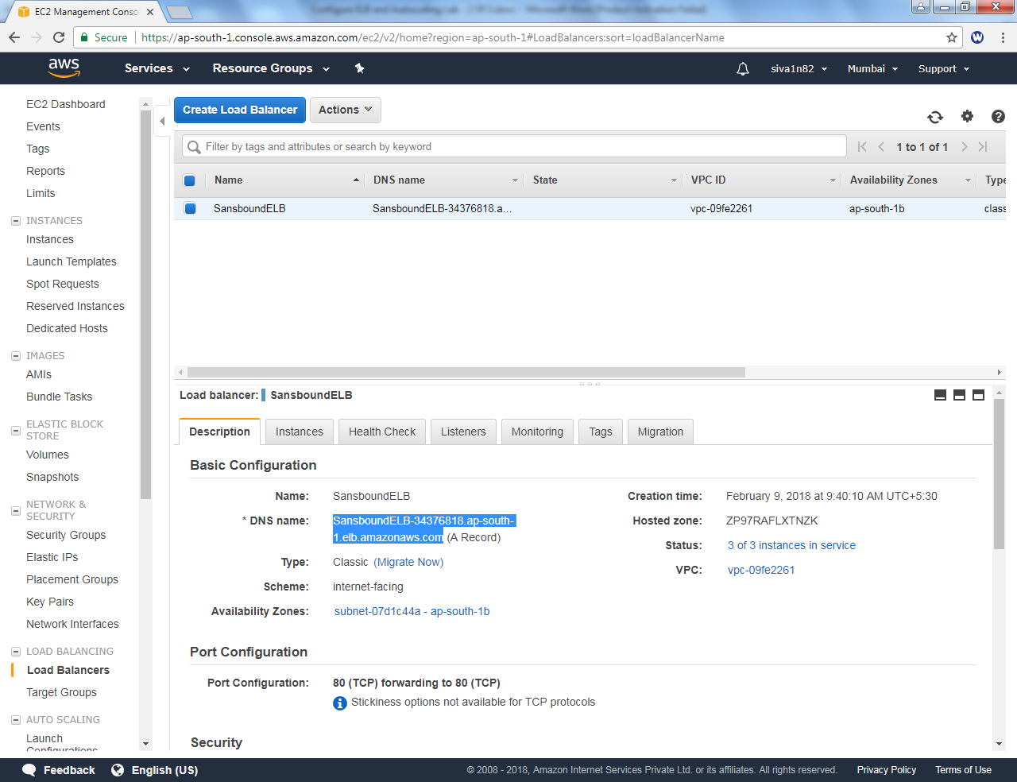

We are able to connect the server successfully.

Webserver1 is connected.



We are able to connect the server successfully.

Webserver3 is connected.



We are able to connect the server successfully.

Webserver2 is connected.

